Laboratorio 9 wilson tarrifa

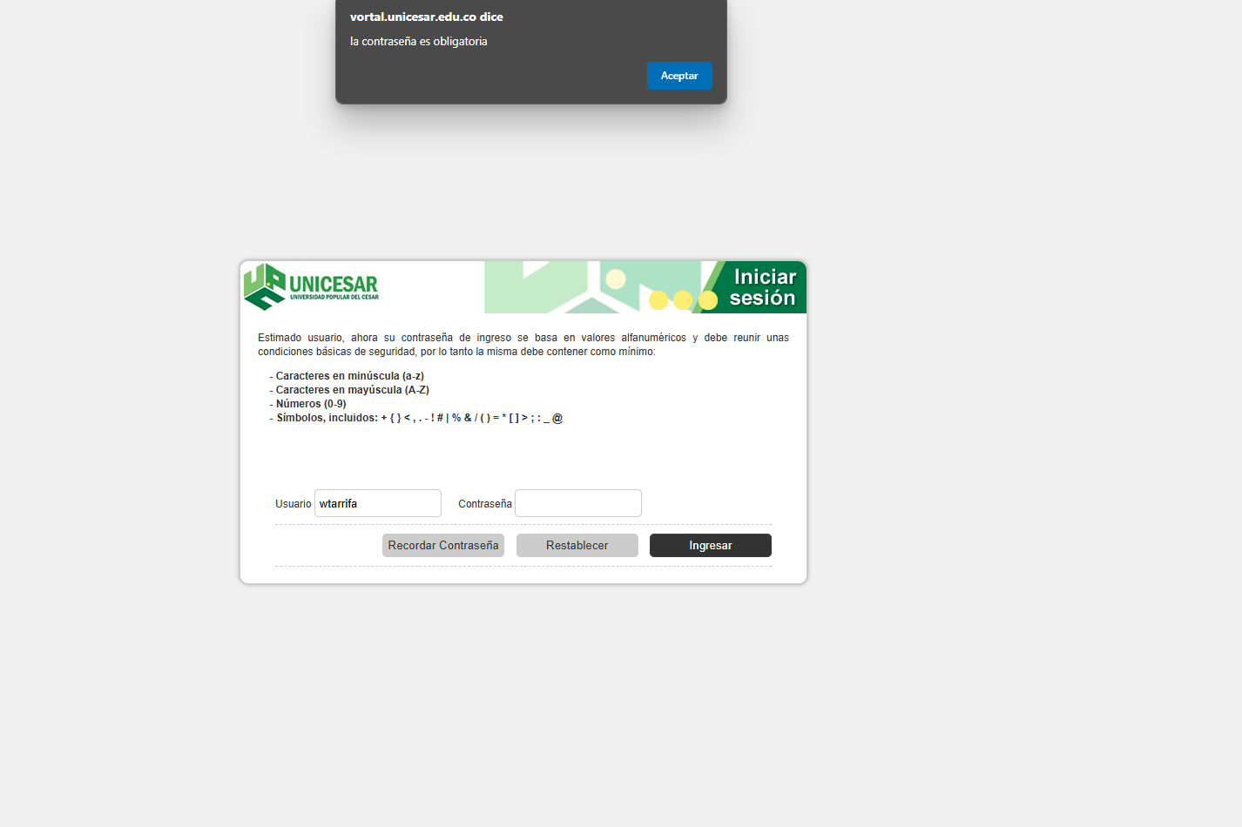

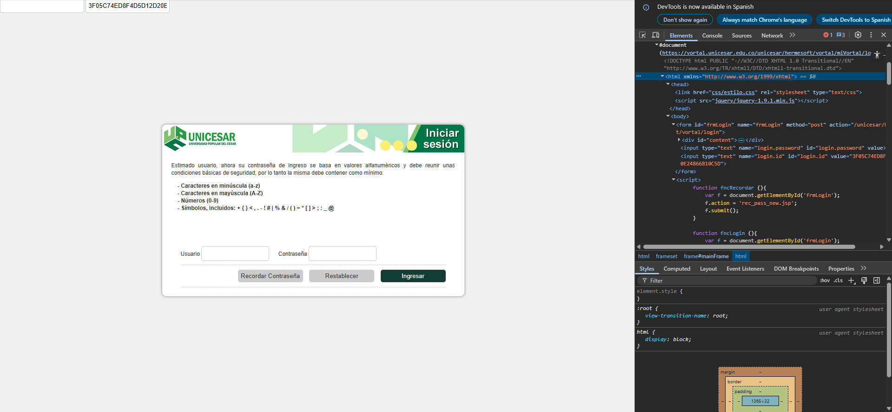

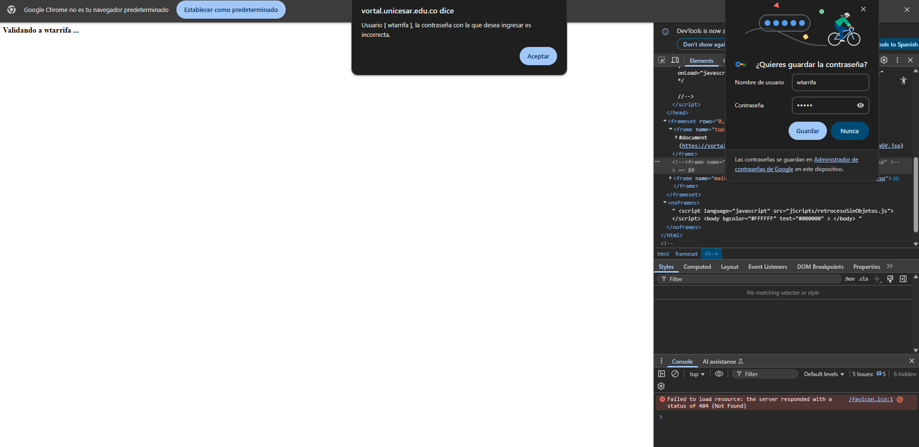

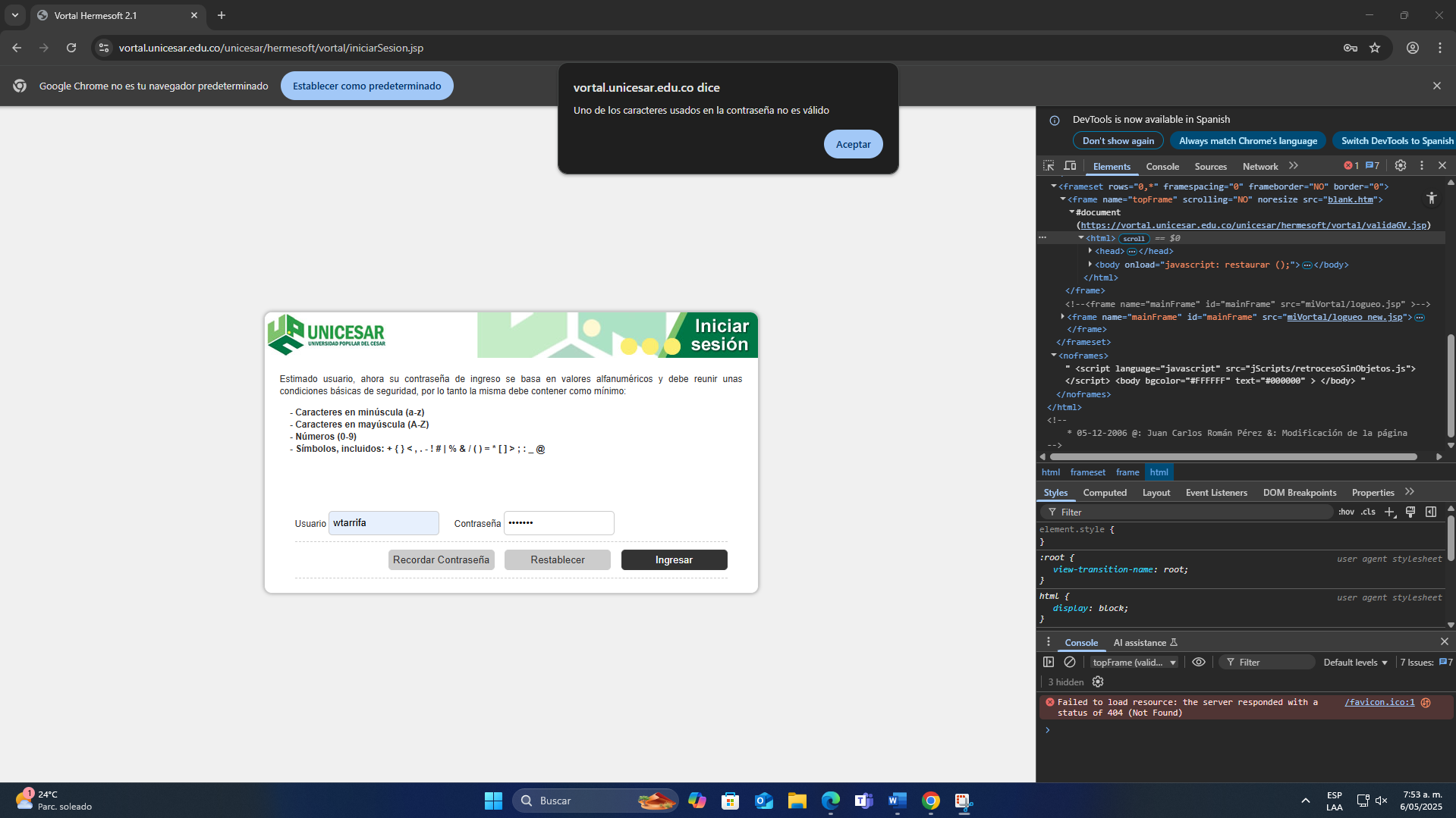

function fncRecordar (){

var f = document.getElementById('frmLogin');

f.action = 'rec_pass_new.jsp';

f.submit();

}

function fncLogin (){

var f = document.getElementById('frmLogin');

var usr = document.getElementById('loginUsuario');

var pwd = document.getElementById('password');

if (esVacio (usr.value)){

alert ('El usuario es obligatorio');

}else if (esVacio (pwd.value)){

alert ('la contraseña es obligatoria');

}else if (!fncVerify (pwd.value)){

alert ('Uno de los caracteres usados en la contraseña no es válido');

}else{

// se deben establecer los valores equivalente a cada caracter y limpiar la original.

var lp = document.getElementById ('login.password');

lp.value = fncAsciiValue ($('#password').val());

$('#password').val('');

$('#btn-restablecer').attr("disabled", "disabled");

$('#btn-login').attr("disabled", "disabled");

f.submit();

}

}

function fncVerify (text){

var v = '', textSplit = text.split ('');

for (var s=0; s < textSplit.length; s++){

var caracter = textSplit[s];

var value = asciiJson [caracter.charCodeAt (0)];

if (!value)

return false;

}

return true;

}

function fncAsciiValue (text){

var v = '', textSplit = text.split ('');

for (var s=0; s < textSplit.length; s++){

var caracter = textSplit[s];

var value = asciiJson [caracter.charCodeAt (0)];

v += value;

}

return v;

}

function fncRestablecer (btn){

console.log ('clickeando sobre restablecer !!!');

btn.form.reset ();

}

function esVacio(valor){

if(valor==null){return true;}

for(var i=0;i<valor.length;i++) {

if ((valor.charAt(i)!=' ')&&(valor.charAt(i)!="\t")&&(valor.charAt(i)!="\n")&&(valor.charAt(i)!="\r")){return false;}

}

return true;

}

var asciiJson = {

"49":"70",

"50":"37",

"51":"13",

"52":"42",

"53":"20",

"54":"21",

"55":"57",

"56":"91",

"57":"81",

"48":"69",

"191":"46",

"113":"74",

"119":"47",

"101":"75",

"114":"93",

"116":"79",

"121":"04",

"117":"88",

"105":"45",

"111":"51",

"112":"09",

"43":"64",

"97":"85",

"115":"02",

"100":"19",

"102":"06",

"103":"63",

"104":"73",

"106":"94",

"107":"53",

"108":"43",

"123":"71",

"125":"29",

"60":"14",

"122":"77",

"120":"32",

"99":"28",

"118":"08",

"98":"25",

"110":"03",

"109":"15",

"44":"12",

"46":"97",

"45":"80",

"33":"16",

"35":"36",

"124":"60",

"37":"17",

"38":"56",

"47":"67",

"40":"95",

"41":"66",

"61":"24",

"63":"68",

"161":"72",

"81":"18",

"87":"84",

"69":"27",

"82":"49",

"84":"31",

"89":"78",

"85":"87",

"73":"82",

"79":"44",

"80":"05",

"42":"30",

"65":"07",

"83":"33",

"68":"55",

"70":"52",

"71":"83",

"72":"48",

"74":"26",

"75":"59",

"76":"11",

"91":"50",

"93":"34",

"62":"86",

"90":"65",

"88":"22",

"67":"54",

"86":"90",

"66":"38",

"78":"76",

"77":"01",

"59":"40",

"58":"41",

"95":"10",

"64":"58"

};

$(document).ready (function(){

$("#loginUsuario").keypress(function(e){

if (e.which == 13){

fncLogin ();

}

});

$("#password").keypress(function(e){

if (e.which == 13){

fncLogin ();

}

});

});

alert ("Usuario [ wtarrifa ], la contraseña con la que desea ingresar es incorrecta.");

